Cash Flow: How to Monitor, Manage, and Model It for Business Success
Cash flow is on every business owners’ mind due to the global economic conditions that the past couple of years has wrought. Understanding cash flow as a concept and as a series of processes helps businesses succeed and has become especially important in an economy like we're experiencing now.
What is Cash Flow?
Here’s a quick definition to start:
Cash flow is the movement of money into and out of - your business. Most businesses have three forms of cash flow:
- Investing cash flow: asset purchase and investments in other business ventures
- Financing cash flow: gains and losses from a company’s debt and equity
- Operating cash flow: money generated by a business’ regular transactions
Let’s focus on operating cash flow. In other words, let’s agree to observe and discuss the daily, weekly, monthly and quarterly business transactions that result in cash entering and leaving your business.
- Operational cash inflow is when revenue from a sale arrives in your business.
- Operational cash outflow is when your business has to pay some sort of bill or expense

Why is Cash Flow Important to a Business?
...or rather, how long can my business exist with no inflow?
While businesses appear to fail for many reasons, the majority of problems are cash management related. Perhaps there’s not enough sales to sustain the business, perhaps important and timely purchases were mishandled, or the business cash position has become negative over a period of time and there’s a final ‘death blow’ in the form of a more acute incident that topples the business (2020 - we’re looking at you for this last one!)
With the right information and management techniques, a business can predict how long they can stay in business - knowing this will help prioritize and plan how you manage your cash...and likely keep you in business longer.
Monitoring Cash Flow: “I need to keep my finger on the pulse of my business”
Each transaction in or out of our business is a piece of data that we can use to measure whether we’re moving toward positive cash flow. We might examine recent financial statements, costs/sales, budget/actuals in order to hone in on important data.
Monitoring cash flow is a low-intervention activity that provides information to support cash management.
We can compare other business’ cash flow data points with our competitors’ if they’re known
We can compare our historical cash flow situation with our present one.
Your goal: To continually observe your own cash inflow and outflow data to find the date on the calendar when your business would have to close due to not enough revenue (runway date). Cash flow is often cyclical so be sure to pick out logical windows of time looking for trends in your business’ cash flow. Logical windows of time might be a year, a season, a week, 13 weeks, or even in some cases, daily.
The measure of success for M1: When you have your business’ potential closing date or runway; you can name the factors that affect your inflow and outflow; you can talk knowledgeably about the cycles your cash flow experiences.
Cash Management: “I’m ready to control my business so I can be proactive about risks and growth opportunities”
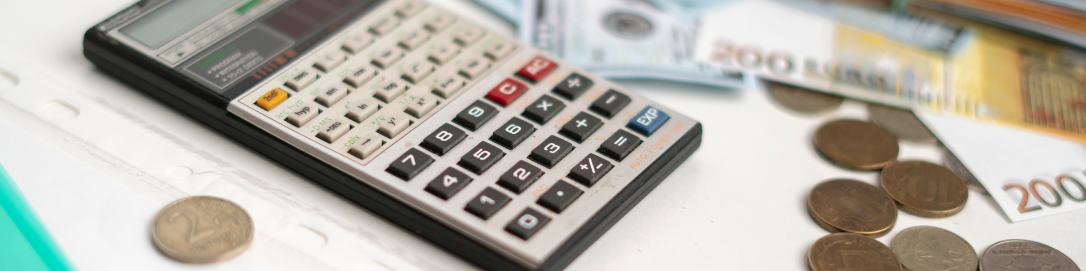
Cash management occurs when a person or process plans and manipulates cash inflows and outflows to extend the business’ runway.
- Cash management is transactional: upselling a product to get more revenue; paying an invoice on the negotiated terms and not before
- Cash management is operational: inventory management, sales, managing payroll
- Cash management is strategic: mid- and long-term planning to advance the goals of business’ ‘best advantage’
Managing cash flow is a high-intervention, high communication activity that uses monitoring information and real-time tools to manage cash with the ultimate goal of achieving and remaining cash flow positive.
Your goal: To manage transactional, operational, and strategic circumstances so that the business can continue to extend its runway.
The measure of success for M2: When your business can extend its closure date through adding to its cash reserves (savings), ably addressing shortfalls, comfortably repaying debt, paying shareholders, or investing in itself - you’re managing cash effectively.

Cash Modeling: “I need visibility around the possible outcomes of future events, and the ability to stress-test my business against internal and external ‘what if’ scenarios”
Cash modeling occurs when a person or group clearly articulates then shows the causes and effects of an event(s) on business cash flow.
- Cash modeling requires an understanding of the business, its cash monitoring findings and cash management practices.
- Cash modeling starts with an idea: “What if X were to happen on [date]?”
- Cash modeling should be approached as a series of quick sketches that can either be discarded or refined as time progresses
- Cash modeling should be considered extensively from both growth and risk angles
Modeling cash flow is a high-value, communication-based strategic activity that uses monitoring information and real-time tools to create and consider ‘what if’ scenarios to plan business movements around risk and growth. All stakeholders should be invited to model out what-ifs that affect their particular domain.
Your goal: To stress-test your business against the most likely scenarios in order to better prepare in case those scenarios come to pass, thereby affecting your runway date.
How you’ll know you’ve achieved your goal: While nothing is assured, an extended sightline along which you’ve plotted various events and their cash impact will help you weather risks and growth opportunities in the future. Stress-tested against a variety of imagined scenarios, the runway will seem solid and long and decision-making is more straightforward. Modeling what-ifs leads to clarity of mind, effective prioritization, action and communication with your team and your stakeholders.

