Failing at Cash Flow is Real. Here’s How to Become Profitable After Failure.

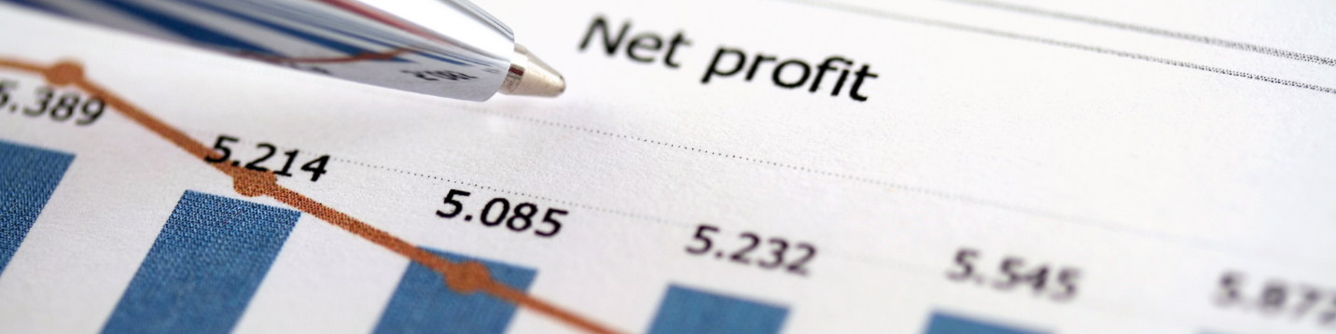

How to recognize poor cash flow and how you can make sure it won’t be a problem for your small business.

Of the 30% of businesses that fail, the reason almost 82% of those businesses fail is because of poor cash flow management (or lack thereof).

What’s really unfortunate is that 70% of the failed cash flow businesses actually became profitable after their failure. A state that could have been avoided had these businesses taken action right away and managed their cash flow better on an ongoing basis.

If you’re reading this article and feeling embarrassed or have that sinking feeling in the back of your mind, you should probably be acting and creating a plan regarding your cash flow. Don’t hold your ground on this one ─ you need to take action now before you become one of that 82%.

Here’s how to help your business become profitable after a cash flow failure (or avoid failing completely).

You may have heard the statistic that many small businesses fail within the first five years. But what we don’t hear is that the reason for this failure is a lack of transparency into their cash flow and a lack of knowledge/expertise with regards to turning this flow around!

Now, the reasons for poor cash flow in small businesses tend to vary. But most fall into one of these categories:

- Poor cash flow management/poor understanding of the flow
- Starting with too little money
- Lack of business plan/poor research
- Improper pricing strategy
- Improper forecasting of sales
- Not seeking professional help or recognizing areas where help is required

But even before you start worrying about bills, the easiest way to tell if you have a cash flow problem is whether your expenses exceed your cash on hand.

In the early stages of business, it is normal for expenses to be higher than revenue. Especially when it comes to marketing, sales, admin, R&D, and anything else you must consider as an operating cost before your business is established. But no matter where you are in your business, your expenses should never exceed your available cash.

Here are 3 ways to manage your cash flow so that your expenses do not exceed your cash on hand:

- Categorize spending

You need transparent insight with regards to what money you’re spending and what you’re getting out of it. Work with your Financial Professional to determine categories for your expenses and see if anything sticks out as odd. You might need to look at the % spent in each category, not just the dollar amount.

- Use benchmarking

To see whether you’re on track, behind, or way ahead of your spending, you need to set benchmarks against other businesses in the industry and see whether you’re executing at a similar level. You don’t want to be ahead (spending more cash than you have), and if you’re not seeing as much growth but are behind on spending, this could give you a good idea why. Adjust accordingly depending on where you want your business to be and on the available cash, but make sure the adjustments are justified and outcomes are measurable.

- Micromanage spending

This part doesn’t seem as fun as benchmarking and adjusting but sometimes, it’s necessary. If you’re overspending a good way to keep track of this without getting too far ahead of yourself is by “nickel-and-diming” yourself.

You should be tracking all your expenses anyways, in order to know what to charge, but if you suspect your cash flow is somewhat limited or lagging, you need to watch every single cent. All money spent is subtracting from your profit margin so it’s extremely important to consider the financial impact of every dollar you spend while your cash flow is struggling.

Use Forecasting to Your Advantage

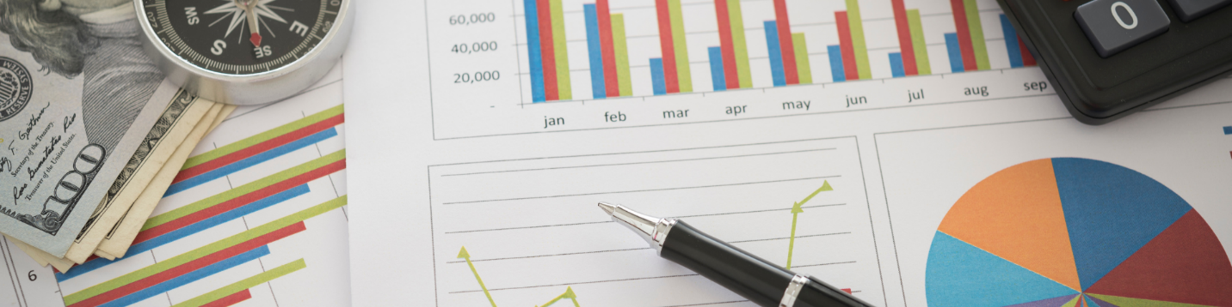

Now that you know how to determine and avoid problems with cash flow, here’s how you can make it work for you.

If you’re not forecasting your cash flow correctly, you will fail. It might be sooner, it might be later, but if you don’t know how much money you’re going to be bringing in (and don’t make it your business to know) you won’t have a business left to turn to.

But the good news is that if you implement the three strategies above, forecasting should be the natural next step for your business.

Just like your business goals, you should focus on both short and long-term forecasting when it comes to cash flow.

Plan your goals in accordance with your purchases and make sure to constantly reevaluate and look at the numbers with your Financial Professional to plan properly and adjust accordingly.

To achieve sustainable growth is a fine balancing act. And while you do need to spend money to make money, the money spent should be planned and justified.

Almost a third of all small businesses in the US say that cash flow will be their biggest challenge in the near future, followed by a lack of consumer demand. In order to get ahead of these problems, managing cash flow will be crucial and, more often than not, the difference between the life and death of these businesses.

─

Are you unsure of your cash flow situation? Are you looking for ways to reduce spending and create sustainable growth for your business?

If you’re worried about your small business or want to create and implement a growth strategy ahead of any potential economic downturn, do not hesitate to contact me today.

