My Business' Cash Flow is Failing: What Do I Do?
Cash flow is the life of a business.
Unless you are running a tech startup that was designed to burn heavily through cash to grow as quickly as possible, the stream of money you have dictates how well the business is performing.
These problems happen to small and large businesses alike. They can hit us without warning or slowly drain the life out of our company. We could have customers who always pay, but they settle invoices on their own schedule. A common source of pain is slow-paying clients. It’s easy for us to overlook the problem as long as the money eventually arrives.
Here are a couple of ideas to follow to ensure your cash flow remains positive:
- Ensure you get paid

The line between slow payments and delinquent ones is very fine. Our companies need to have policies that state how quickly we expect to be paid. A client could be unaware of the problem or taking advantage of vague terms that we set in place. Adding explicit wording to our invoices that demand payment upon receipt or within 30 days makes it clear, and tracking these invoices ensures they won’t get lost in the noise.
If we have a process in place, when a customer doesn’t pay, wheels are already turning. Seeing exactly when there is a problem allows us to switch to collection mode, first trying to work with the customer and then following up with third-party collection services.
- Mind your expenses
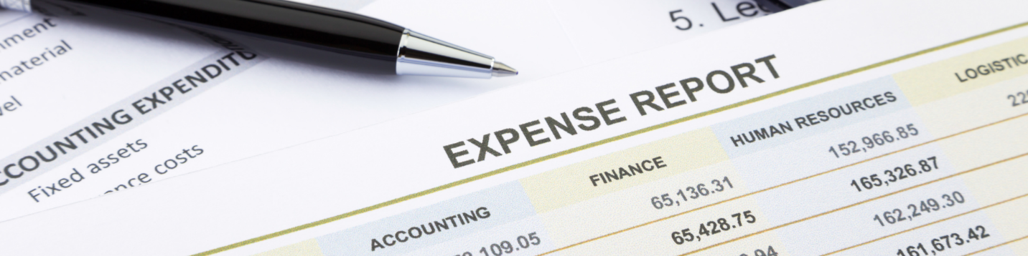
When cash is coming into the business without issue, expenses may be the problem. It is too easy for us to become complacent with expenses. Cash flow crunches could come from unexpected large expenses like equipment breakdown, glitchy tech, and natural disasters. Unnecessary expenses can also slip through without us realizing it. Having the proper accounting tools are imperative for tracking every cent that enters and exits the business. Identifying the leaks is the first step towards getting your cash flow under control.
- Forecast ahead
Our companies also need to understand how our current cash flow is going to affect the future. Looking into cash flow projections allows us to be proactive. We can eliminate issues before they arise, curb spending before it gets out of hand, and plan for large expenses. A six-month cash flow projection that has accurate visualizations of expected revenue and expenses will allow us to be prepared and resilient.
- Hire a Professional
Staying on top of these issues is best left to the experts. Having a competent Financial Professional involved with our business allows us to accomplish all these tasks and stay ahead. For the more complicated operations, talking to experts that can provide perspective and help for managing the cash flow of your business helps create transparency for your financials. They help you understand your true cash flow Runway and what steps are necessary to manage it moving forward.
If you feel you could benefit from a practical and experienced fractional CFO for the construction industry, please connect on LinkedIn and message me to set up a time to discuss what you would like to accomplish within your business and a plan to get you there.

