Slowing Down During Chaos
"Slow is Smooth - Smooth is fast." - SAS Special Ops Training Proverb
In our frantic scramble to get as much done as possible, it’s easy to lose track of what’s important. We gloss over things because we don’t have the time to explore them in-depth. Important insights and key pivotal decisions sit idle in our reports as we move on to the next thing, the next distraction.
Now, through much of the past couple of years, we’ve been thrown to the wolves and left to bob and weave just to try to stay alive. But this isn’t what this unprecedented time has to mean for you and your business. You don’t have to maintain the status quo when that has already been disrupted. Right now can be a crisis or an opportunity.

It doesn’t always have to be fast.
The pace of business is accelerating. The ability to get things done faster is driving us to do it. We are focused on how many tasks we get done. What matters is how many boxes we get checked at the end of the day. When things are moving fast, we just move faster.
Now, more than ever, that might not be the smart move. Instead of jerking from one distraction to another, step back and regain your focus. Now might be a time to slow down. Take a breath, and reevaluate where you are and where you want to go.
It seems counterintuitive. Our thoughts when we are hit with a crisis is to try to do more. We want to solve the problem quickly and intend on doing that with brute force effort.
But that isn’t the best thing to do when the grenades go off. Special operators in the SAS have a saying, “Slow is smooth, smooth is fast.”
Special operations units are full of people who know how to perform under pressure. They are weeded out from the general ranks for displaying just this attribute. But when things go sideways, they don’t speed up. They slow down.
Scientists have studied spec ops soldiers to see what makes them different from civilians when the pressure is on. When the stress is at its peak, and their lives are on the line, they don’t freak out. They get calm. Their heart rates will actually drop once they are under fire. The blood pressure of bomb disposal experts will drop as they approach an IED.
They know what we don’t. If you slow down and keep calm, that’s when you will make the right decisions. Maintaining your feeling of control keeps you in the driver’s seat. Preparing your emotions and keeping in mind that things could always get worse keeps things in perspective. You never want to panic.
When we panic, we make mistakes. We override systems that are functioning properly. We disregard our standard procedures and ignore the rules we’ve put in place for just these scenarios. We deviate from perfect plans. We stop thinking, and we start reacting.

Rethink your strategy
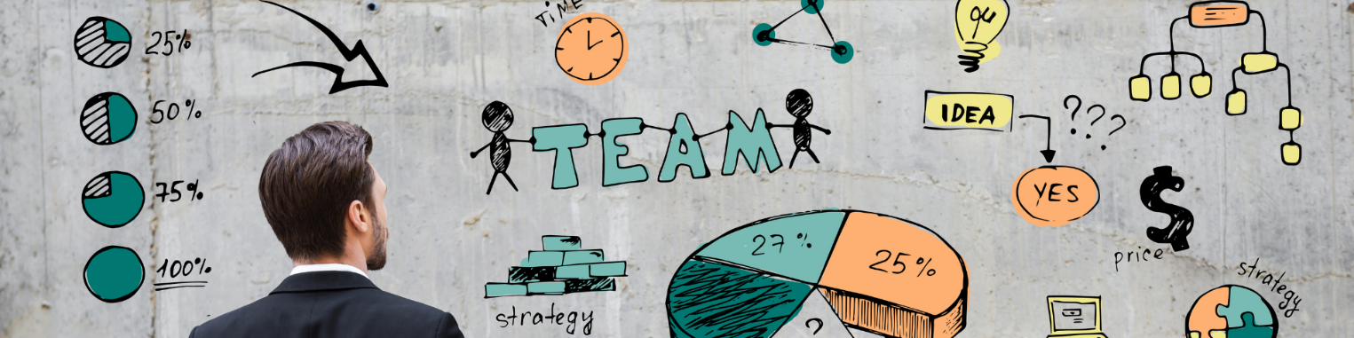
You likely don’t have to worry about taking heavy fire from an enemy. There aren’t any mortar rounds coming your way, but that doesn’t mean you aren’t in a stressful situation. Lives aren’t on the line right now, but jobs could be.
For most businesses, this is a critical time. It is a raging fire that will end one of two ways. It will make your business stronger, or it will break you.
Now isn’t the time to panic. Take the time to slow down and really think about what is important for your business to come out of this pandemic stronger than when it was thrown in.
Focus on doing the right things, not just staying busy. When we are charging forward at all costs, we have too much forward momentum to reroute if we go off track. Getting to the wrong place quickly isn’t useful for anyone.
What misleads us is that the entire time we feel like we are making progress. We feel obstacles fall at our feet, and we revel in the accomplishment. But being successful at the wrong thing doesn’t get the right tasks accomplished. In fact, you’re farther away because you’ve wasted so much time and effort.
Go back to the board and rethink your current strategy. Cut losses on projects that aren’t working out and double down on what is. This is a time to pair down and make your operation lean and efficient.
Put some quality effort into not just putting out fires, but figuring out where these fires are coming from and preventing them from happening in the first place.
Revisit your four quadrants of time management. The urgent crises of Q1 are probably long gone. What is left is the residual chaos—those day to day interruptions that are draining your focus and your productivity.
Set aside some quality time to get some Q2 activities accomplished. Put processes in place to prevent chaos from taking over. Plan your next moves. Determine where you have the most room to improve and figure out how to accomplish it.
The thought that you put in now is going to determine where your company ends up whenever things go back to normal. Thinking longer and harder than your competitors is what will help you come out of 2020 more robust and primed to pounce on growth opportunities when the markets bounce back.

Final thoughts
These are stressful times, but if we want to come out of them better off, we can’t fall into panic. We need to stay in control and take advantage of the opportunities that the situation is giving us.
By slowing down and stepping back to think and strategize, we can find those hidden insights we’ve been overlooking. We can explore situations in-depth. Instead of being distracted by the chaos around us, we can slow down and focus on making the right decisions. That is what will help our businesses run smoothly.

