Top Cash Flow Issues for Restaurants and Bars
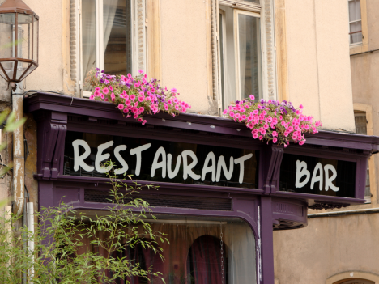
Cash reserves provide the means for paying employees and suppliers and meeting obligations. For small businesses, a reliable cash flow stream is crucial to survival and success. Therefore, plans for cash flow should never be an afterthought.
The COVID-19 pandemic was an eye-opener on why stable cash flows and balances are crucial to the survival and health of any business. Unfortunately, many restaurants and bars chose to close shop a few weeks into the pandemic as they did not have sufficient cash reserves to pay employees, let alone settle utility bills.
At the height of the pandemic, financial institutions became highly cautious about lending. This hesitation was due to the uncertainty that the pandemic triggered, which made access to capital limited. As a result, small businesses, whose cash reserves were depleted, had no option but to go to moneylenders or close shops.
According to JPMorgan, median small businesses have an average daily cash outflow of $374 and an average daily cash inflow of $381. However, the inflows and outflows vary widely depending on the industry. The restaurant industry sees the most significant disparity, with a daily cash outflow of $957 and inflows of $968.

A big concern is that median businesses such as restaurants and bars hold an average daily cash balance of $12,100. The JPMorgan report also indicates that the median small businesses have 27 cash buffer days in reserve. While 25% of the small businesses hold fewer than 13 cash buffer days, it affirms how vulnerable most businesses are to any capital-draining event.
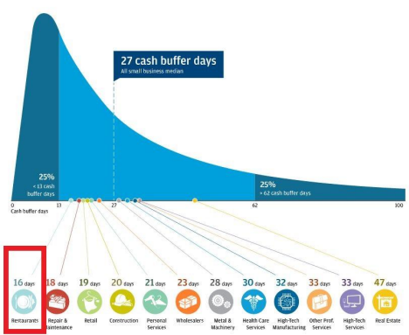
This eye-opening report can be visited here:
https://www.jpmorganchase.com/institute/research/small-business/report-cash-flows-balances-a nd-buffer-days.htm
Top Cash Flow Issues: Why and How to Solve Them
Most restaurants, bars, and other small businesses are at risk of going under because of cash flow issues which remains the primary cause of most business failures worldwide. In addition, most businesses will encounter cash problems at some stage in their life cycle. Therefore, being aware of the top cash flow issues is crucial for the survival and well-being of any small business.
Below are the top cash flow issues that any business savvy, restaurant, or bar owner should know before things get out of hand.

Top Cash Flow Issues for Restaurants and Bars Part 1: Know Your Primary Numbers

Failing to plan is a costly mistake in business. You can only know your preliminary numbers by preparing adequately. The lack of a disciplined approach to financial planning has seen even the most brilliant ideas dissipate in thin air. The lack of a disciplined approach to financial planning is one of the leading causes of cash flow shortages.
Most businesses forced to close shop or suspend operations at the height of the pandemic were subject to a lack of a detailed forecast, financial plan, or budget. Consequently, it’s become clear that any business's survival depends on how the owners anticipate and plan for unexpected events. Therefore, a financial plan and a budget are crucial in this case.
A detailed financial plan makes it easy to foresee potential cash flow shortages that threaten the business's survival. In addition, the plan would highlight the necessary measures to avert the risk of running out of cash reserves at a critical juncture or when faced with significant issues.
A proper financial plan ensures the business has sufficient cash in reserve to handle even extraordinary emergencies.

Top Cash Flow Issues for Restaurants and Bars Part 2: Manage Staff Levels and Avoid Growing too Quickly

Any business looking to avert cash flow issues must have a framework for managing staff levels all the time. The idea is to ensure labor costs don’t exceed the sales generated at any given period.
For instance, the business can keep staff levels low when the business is slow to keep operational costs down, thus generating optimum profit from the sales made. Additionally, the restaurant or bar can hire more staff during peak seasons, such as summer or holidays, to address the high demand to generate more sales, thus higher free cash flows.
While the ultimate goal of any business is to grow, moderation avoids straining the underlying business financially. For example, opening new restaurant chains or bars in a different location can cause cash flow issues and hurt the business if done quickly without securing cash flow streams and ensuring business stability.
Expansion should only be done if the existing business is profitable and generates sufficient cash flow to sustain the current business's extension. However, if hurriedly, cash flow from the existing business would be used for unnecessary expenditures in the other business whose future is uncertain, putting the overall business in a dire cash flow position.
Expanding too quickly while overestimating future sales is another catastrophic mistake that can hurt cash flows and threaten the business's survival. Even if sales have been on an uptrend calling for expansion, it is essential to be cautious when relying on estimates to predict the future. Some businesses have run into trouble for wagering sales they expect tomorrow and embarking on aggressive plans.

While a sales forecast is essential, it is crucial to create a business plan that guides the entire expansion plan based on the overall sales numbers rather than estimates.
If you liked part 1&2 of this twelve-part series on ”Top Cash Flow Issues for Restaurants and Bars,” please like and share them. Then, make sure to check out part 3&4.

Top Cash Flow Issues for Restaurants and Bars Part 3: Declining Sales and Profit Margins

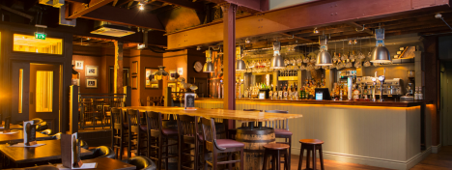

Declining profits and margins have to be the leading cause of shrinking cash reserves or cash flows in most businesses. This decline was evident as the pandemic struck. As governments banned and dissuaded people from dining or drinking, most businesses were deprived of crucial revenue streams.
Restaurants and bars with insufficient cash reserves paid the ultimate price as they could no longer sustain their operations on the lack of sales. While a pandemic is a once-in-a-lifetime event, businesses must plan for declining sales or profit margins. In addition, a reduction in sales leading to cash flow issues can come into play due to increased competition or a decline in sales across the entire industry.
Softening economic conditions, such as a spike in inflation, may hurt sales significantly, leading to cash flow issues. Should operational costs stay the same amid declining sales, then a small business without any other source of income could find itself in a dangerous financial situation.
In addition to declining sales, softening profit margins can take a toll on free cash flows. Therefore, even if sales are increasing at a high rate but the profit margins are small, then the financial health of the business will be impacted negatively, given the low free cash flows that come into play.
In this case, the idea is to ensure that the business can generate optimum profit from each product or service sold. Therefore, effective pricing strategies should be deployed to create a business that can generate maximum sales and generate optimum earnings without scaring customers.

Top Cash Flow Issues for Restaurants and Bars Part 4: Update Your Menu and Avoid Bad Pricing

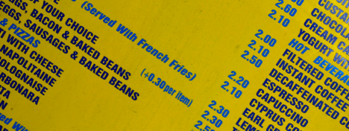

Change is constant. It is also the only way any bar or restaurant can stay ahead of the competition and attract more sales at any given time. To keep your restaurant or bar afloat, updating the menu is crucial.
Even if the current menu has served customers well, tweaking it a little bit is essential to attract more customers and generate more sales. Updating the bar and restaurant menu helps address guests changing tastes, therefore, holding on to the current customer base and attracting new ones. In addition, it is essential to research and sees what’s hot and in demand in the market, be it on the product offering or service delivery, to keep the business going.
Additionally, updating the menu helps bars and restaurants adjust to specific seasons. For instance, it could lead to cheap seasonal ingredients, thus leading to higher profit margins and more free cash flows.
The business could also resort to selling a particular set of drinks that are in demand using seasonal ingredients, and beverages can give a business more profits while lowering costs. They could also go a long way in attracting more customers.
Updating the menu would also touch on pricing. Whenever food or drink prices increase, the bar or restaurant must also respond adequately and competitively to protect profit margins and, thus, cash flows. A business that stays rigid without updating its pricing strategy is always at risk of entering into cash problems down the lines on dwindling profit margins.
A business that gets it right on pricing is always assured of drawing in consumers and shunning stiff competition. This truth goes a long way in generating significant sales that bolsters cash flow and cash reserves.

If the pricing is too high, the restaurant or bar could scare customers, forcing them to seek similar products and services elsewhere. But conversely, if the pricing is too low, the business could miss out on crucial revenues needed for high-profit margins, thus high free cash flow.
When pricing is a way of averting cash flow issues, it is essential to pay attention to the competition. However, you don’t need to undercut the competition significantly to draw in customers or charge low to fuel demand. The idea is to strike a balance and settle on a competitive and suitable price.
If you liked part 3&4 of this twelve-part series on ”Top Cash Flow Issues for Restaurants and Bars,” please like and share it. Then, make sure to check out part 5&6.

Top Cash Flow Issues for Restaurants and Bars Part 5: Make Seasonal Budgets

Impulsive spending could also trigger significant cash flow problems. Therefore, while the ultimate goal is to do everything to ensure the business's success, caution is of utmost importance until cash streams stabilize. Making seasonal budgets is crucial to avert the risk of impulse spending.
It is, therefore, important to only spend on the necessary items and make critical investments that have the potential to increase cash flow streams. Restaurants and bars that overspend on designs, outlook or even stock end up paying a hefty price in the long run when sales fail to hit the desired levels. Likewise, impulsive spending on products and solutions that become obsolete over a short period without the business accruing a significant return on investment is a catastrophic mistake.
Therefore, a business needs to establish a budget for spending based on the underlying cash flows. This structure will go a long way in setting the baseline for spending and avoiding using much-needed capital on unnecessary items.
To avoid impulsive business spending, use financial software or a spreadsheet to monitor and categorize all outgoing expenses. You can also set up a reward system to recap business spending patterns and financial milestones.

Top Cash Flow Issues for Restaurants and Bars Part 6: Avoid Relying on Credit and Late payments

Drowning in interest payments, or a slow death by a thousand paper cuts. Two expressions that paint the picture of the suffering so many business owners experience when they get caught in the credit trap.
Offering credit affirms trust to customers. A loyal customer will always choose your restaurant or bar over other outlets, given the belief accorded through credit. However, when overdone, credit can affect cash flow significantly. Therefore, maintaining a framework that ensures credit does not exceed a given limit is essential to ensure the business protects its cash flows while keeping debts low.
In addition, the creditworthiness of every customer should be assessed. It is vital to ensure that credit is not given to customers that consistently default on payments. While setting a credit limit is a complex and judgmental process, it is crucial to avert critical cash issues down the line.
Late payments can considerably strain a business's cash flow stream. For businesses that offer credit, it is vital to have some cash buffer to cater to other operations while awaiting payments. Customers take, on average, 36 days to pay invoices calls for an alternative cash flow option. Therefore, it is essential to assume that the debtors will take some time before paying and preparing adequately.
If you are struggling with overdue payments that trigger cash flow issues, you can clarify the terms and expectations on every invoice. In addition, you can always ask for a deposit or total payment upfront to avoid such stalemates. Finally, automatic payment reminders can always come into play or charge a fee for late payments as a deterrent to people holding on to payments for a long time.

If you liked part 5&6 of this twelve-part series on ”Top Cash Flow Issues for Restaurants and Bars,” please like and share it. Then, make sure to check out part 7&8.

Top Cash Flow Issues for Restaurants and Bars Part 7: Rely on Multiple Vendors

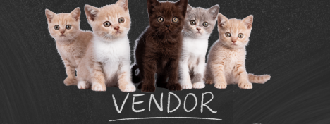

While working with multiple vendors in the supply of goods and products adds complexity to the supply chain, it is essential. It helps address cost issues that eat into profit margins in the restaurant and bar business. In addition, dealing with multiple vendors often leads to competition, forcing the suppliers to improve the cost of goods and products they offer.
The competition can lead to a business securing products and goods at much-reduced prices, leading to increased profit margins on sales. In this way, the business can generate more free cash flow. In addition, fewer bottlenecks are usually at hand as more vendors can supply to meet peak demand, allowing the bar restaurant to generate optimum cash flows during peak season.

Top Cash Flow Issues for Restaurants and Bars Part 8: Inventory Management

Excess stock without significant sales starves a business from the much-needed cash it needs to operate. For bars, it is essential to have an effective inventory management system to avoid overspending on a stock without any forthcoming sales. Too much inventory in-store does not amount to any liquid cash that the business can use to finance other operations.
While there is always the prospect of enjoying significant discounts on buying in bulk, failure to turn over the stock quickly could be catastrophic. In addition, the stock could become obsolete and unsellable, leading to a significant loss of potential income.
Therefore, it is essential to find a balance in inventory management. A strategic approach will ensure a business enjoys economies of scale while at the same time turning over stock quickly and enjoying big margins.
Any business looking to enjoy solid cash flows must maintain a robust inventory management system to monitor inventory levels. This is the only way a business would be able to move stock, generate significant cash flow, and avoid any cash issues in the future. It is also good business practice to refrain from ordering more than the business needs.

If you liked part 7&8 of this twelve-part series on ”Top Cash Flow Issues for Restaurants and Bars,” please like and share it. Then, make sure to check out part 9 &10.

Top Cash Flow Issues for Restaurants and Bars Part 9: Consider Overhead Cutbacks

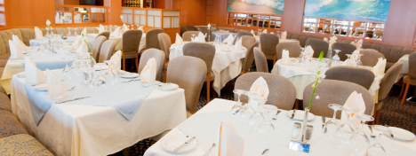

One of the biggest mistakes most bars and restaurants overlook is overhead costs. If such costs are high compared to the number of sales the business generates, the likelihood of running into cash flow issues is generally high. In addition, with high overhead costs, the business will have to ramp up sales to cover the unexpected expenses and break even.
Some overhead costs that bars and restaurants should pay close watch include rental costs. While having a business in a strategic location is the ultimate goal, if all the money generated goes into paying rent, leaving none for operations, it would not make any business sense.
Labor costs are also overhead costs that small businesses should pay close attention to, especially during peak periods. While hiring additional staff during peak season is common, it should be done in moderation to avoid hurting margins due to increased operational costs.
Reducing overhead costs can go a long way in making a long-term difference in the business's profitability, avoiding cash flow issues in the long run.

Top Cash Flow Issues for Restaurants and Bars Part 10: Funding Facilities

Funding facilities could also be the source of cash flow issues if a business does not evolve with time. Just because a financing solution worked when the business started does not mean it will continue working as it grows and faces new challenges. Therefore, to avoid any cash issues in the long run, a business should look for ideal financing solutions with better and friendlier terms.
Businesses that rely on financing solutions such as business loans to operate and expand are always at risk of experiencing cash flow issues. Sometimes, financing can be complex, leading to severe cash flow problems. For instance, one could be denied funding because of lousy credit or inadequate collateral.
While trying to avoid cash flow issues in the future, it is crucial to benchmark current funding solutions while comparing them with other products in the market. In addition, it is essential to check if there is a better fit for the business to ensure the business ends up with a financing solution that is not only reliable but also affordable.
The current business environment is under immense pressure than ever amid rising inflation. Central banks hiking interest rates to stem the runaway inflation presents new challenges. A spike in borrowing costs due to a spike in interest rates is one reason to be looking for other affordable financing solutions from the ones the business is used to.

If you liked part 9&10 of this twelve-part series on ”Top Cash Flow Issues for Restaurants and Bars,” please like and share it. Then, make sure to check out part 11&12

Top Cash Flow Issues for Restaurants and Bars Part 11: Save for a Rainy Day

Businesses that deal in consumer goods feel the brunt of seasonal changes, affecting consumer spending patterns. For instance, sales and revenue are much higher during the holiday season and slower during other times.
Restaurants and bars, like any business, experience different cycles. Peak periods are characterized by a booming business not limited to economics. Peak periods are some of the best, as sales tend to increase significantly. During this period, businesses operating optimally can generate significant sales leading to more profits and thus free cash flows.
However, it is essential to note that extra costs may come into play during peak periods, especially when hiring more staff or acquiring new stock to address high demand. Therefore, businesses should balance increasing sales and emerging costs to make significant profits.
A business that fails to generate substantial sales and optimum profits during peak periods faces the risk of cash flow issues during the off-season when sales are lulled. The cash issues may be exacerbated further if the business deals with many debtors who are not paying on time.
The best way to avoid seasonal cash flow problems is to plan accordingly and save for a rainy season during peak periods. Therefore, the idea is to ensure that a business operates optimally during the peak periods and generates optimum profits, thus significant cash flow which can be used during periods when business is low.

Top Cash Flow Issues for Restaurants and Bars Part 12: Ask for Deposits

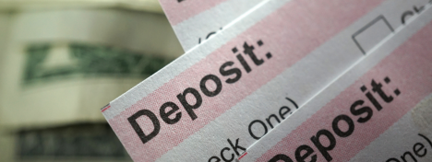

Running a busy bar or restaurant requires the correct number of staff, food, and drinks. The balancing act that goes into play can be costly if customers book in advance and don’t show up. Whenever customers make bookings in advance, most businesses hope they turn up. If the customers don’t, it could lead to a significant loss of revenues and thus cash flows.
Most bars and restaurants are increasingly taking a stand against people who make bookings and don’t show up in a bid to secure key revenue streams and cash flows. Charging a deposit payment is turning out to be the ultimate answer to reducing no-shows among people who make bookings and reservations.
With the booking payment system, a restaurant or bar can call people who have made reservations if they fail to show up at the time. If they confirm they are not coming, it becomes much easier to resell the table, therefore, securing crucial sales with other customers.
Bottom line
Restaurants and bars continue to face challenging times. Adequate planning is crucial to surviving the onslaughts triggered by cash flow issues that might come into play from time to time. While cost-cutting is a proven strategy for conserving cash reserves, adjusting the business strategy may go a long way in helping the business stay cash positive.
If you liked this twelve-part series on “Top Cash Flow Issues for Restaurants and Bars,” please like and share it.

