Understanding the Thought Chain of Handling an Emergency Cash Shortage

The thought of going through an emergency cash shortage is at best, terrifying. Especially since for many businesses, if happened not so long ago due to the COVID crisis.

While businesses focused on protecting their employees as best as they could, the underlying damage to the economy became stronger with every passing day. But one thing we do know for sure is that businesses around the world were taken by surprise at this turn of events and many have suffered greatly.

Experiencing an emergency cash shortage often takes most people by surprise. It isn’t something you’re expecting, but you can be prepared for the worst and come out much better than had you not prepared at all.

Here’s how you can prepare for handling an emergency cash shortage:

Have good books

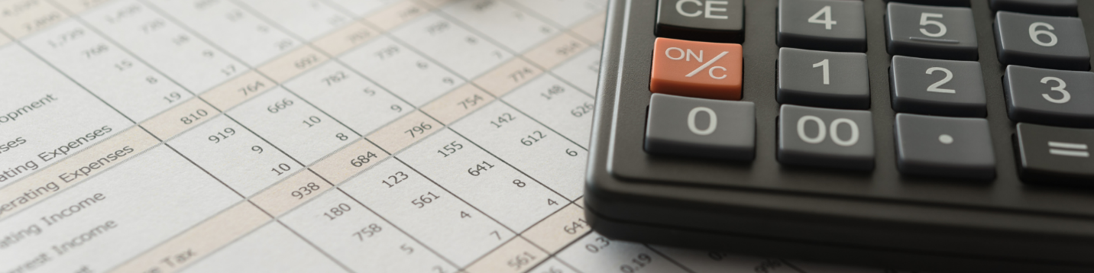

By keeping up with your books and keeping up-to-date records, you’ll have a better idea of where your business stands on a day-to-day basis and will be able to foresee any potential hurdles well in advance. This way, when an emergency arises, you’ll have an idea of how much you can stretch and what next steps to take to get yourself back on your feet.

Know your runway

Knowing your runway is another term for knowing how long your business can survive given its current cash standing. By knowing your runway, you will be comforted in knowing what level of performance you can afford to maintain should your business encounter a rough patch at any point.

Check undeposited funds

Many businesses may have checks they have not cashed or potentially funds that have not been counted. While it's best practice and important to account for these funds when they are received, in this case it is better late than never.

Check outstanding receivables and follow up immediately

Checking your accounts receivable is another easy way to find outstanding funds that can be added to the pot right away. Following up on accounts that are upcoming or just past due is a quick way to add to your cash flow. Often, accounts that are just past due have simply forgotten. A quick and friendly reminder can go a long way.

Factoring is an option

If you are all updated on your accounts receivable or have done everything you can do in that department, you can factor your upcoming invoices. What this means is taking out a loan against your upcoming invoices that are from accounts that are in good standing. If you know these accounts will pay, you can get credit against the amount due on their invoices, and simply repay it once the invoice is paid up.

This gives you some cash flow for the immediate future so you can continue operations, while not putting you behind by taking out a loan.

Make quick sales

Is there anything you can push sales for that convert quickly and have a high margin? If so, now is the time to start promoting these products or services. For example, accountants may want to start early promotions on tax services or offer a small discount for new clients that agree to take on a contract of a certain duration.

Line of credit

Opening a line of credit may not be ideal for some businesses but if you have an agreement for a contract that is set to go through in the near future and just need to sustain your business until then, it can be a great option. Similarly, if you’re waiting on payment of a large invoice or need funds to start production for a large invoice, a line of credit can be a great option since the invoice is proof that you’ll be able to make good on the line of credit.

Is your family on payroll - maybe able to defer?

If you’re really in a pinch and you have family members on the payroll, could they potentially defer their payments until after you’re through the rough? While not ideal, many family members are willing to make a sacrifice for the business if it means they will be able to keep their jobs once you’re through the woods.

Shareholder loan

A shareholder loan is when an owner or majority shareholder is able to take out a loan against what they have initially invested in the business. This is on the books as a shareholder loan and must be repaid to the business at a later date but is able to provide some quick cash for the time being in order to cover payroll or other expenses.

When are taxes due?

Consider when your taxes are due and whether they can be deferred. During the COVID 19 crisis, many governments offered deferrals to small businesses or self-employed individuals, so that they could continue operations. Consider a deferral if possible and consider whether paying your taxes late could potentially be worth the penalty.

Are payables able to be deferred or is a payment plan an option?

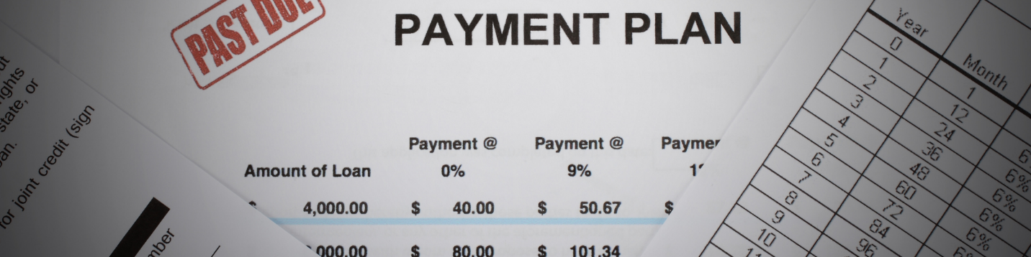

Finally, consider whether your accounts payable are able to be deferred or whether a payment plan is feasible with your suppliers/accounts. Some suppliers have offered deferred or extended payment terms throughout COVID, which has been a huge saving grace for many small businesses. If this is an option, and you’ll be able to repay them later (you’re not putting yourself in a deeper hole) then it is an option worth taking.

─

Have you considered all of these steps when it comes to understanding an emergency cash shortage? If not, it might be time to start thinking about your options and prepare a plan!

