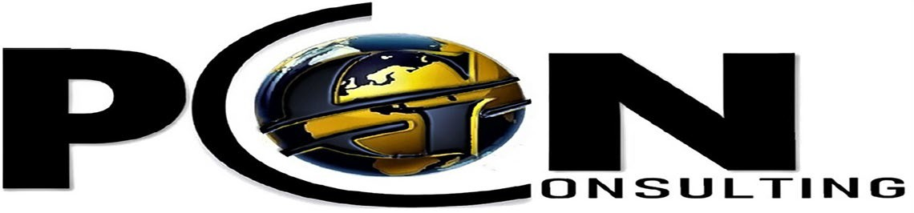
5577 Airport Highway#200
Toledo, Ohio 43615 www.pgnconsulting.org

PREVAILING WAGE/DAVIS-BACON COMPLIANCE SERVICES

Certified Payroll Reporting Software

PGN Consulting offers a proprietary software program and compliance services that make it easier for governmental entities and contractors to set-up, monitor, track and report labor and workforce activities on construction worksites that ensure compliance with laws governing the Davis -Bacon Act or state and/or local laws/regulations governing prevailing wage.

LABOR COMPLIANCE MONITORING SYSTEM CAPABILITES

- Permit contractors to electronically submit and digitally certify payroll reports | - Audit Certified Payroll Reports (CPR) for compliance with State and Federal labor standard
- Automatic upload of State and Federal prevailing wage determinations | - Provide training for applicable staff and contractors
- Provide live technical support for applicable staff and contractors | - Ability to correspond with contractors including sub- tiers
- Ability to upload employee data and wage data from commercially available payroll systems | - Automatic notices to contractors
- Ability to electronically submit results from employee job-site interviews | - Easy to use/intuitive user interface
- Ability to generate reports | - Workforce reporting
- Internet-based

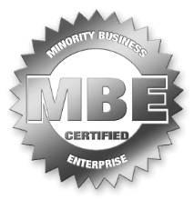
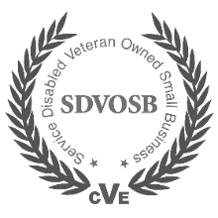
John Tooson IV, CEO
john@pgnconsulting.org (419) 349-2664
Calvin Brown, COO
calvin@pgnconsulting.org (216) 926-7389
77 Airpo

